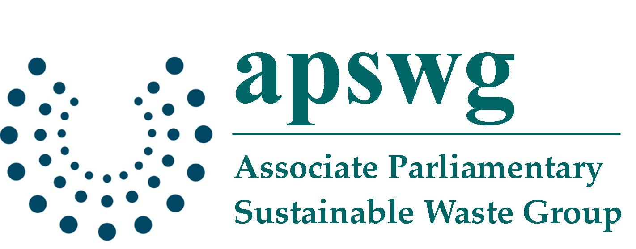

Pay By Weight

An Information Reception and Seminar on Household Rubbish Charging

4 pm - 6 pm, 15th November 2006

Dining Room A, House of Commons

Variable charging (households being directly charged according to the amount of rubbish they put out for collection) has received growing public and political attention. Both central and local Government have shown increasing support for the issue while at the same time press reports have identified public concerns about ‘spy in the bin’ chips and double taxation.

The Associate Parliamentary Sustainable Waste Group, in association with the Chartered Institution of Wastes Management and PM Group plc, are hosting this reception and seminar to help bridge the knowledge gap and increase understanding about how pay by weight could affect household behaviour.

Pay by Weight:
An Information Reception and Seminar on Household Rubbish Charging,

Wednesday 15 November, 16.00-18.00

Dining Room A, House of Commons

4.00 pm Coffee and Refreshments
4.30 pm Introduction from chair: Dr Alan Whitehead MP
Co-chair, APSWG
4.35 pm Geoff Mountain
Chief Executive, PM Group plc

Geoff Mountain will provide details of the technology behind weighing
waste, and outline how any difficulties, such as fly-tipping and waste
transferral, can be overcome.
4.45 pm Steve Lee
Chief Executive, Chartered Institution of Wastes Management

Steve Lee will be speaking on the wider benefits of pay-by-weight.
4.55 pm Hugh McElvaney
Managing Director, McElvaney Waste and Recycling

Hugh McElvaney will outline his experience of the pay per-weight-
system in Ireland.
5.05 pm Cllr Mike Haines
Deputy chairman of the Local Government Association’s
Environment Board

Cllr Mike Haines will discuss the local issues surrounding pay-by-weight
implementation.

5.15 pm Questions from the floor
5.35 pm Coffee and Refreshments
DIRECT CHARGING FOR RUBBISH ALLOWS
PEOPLE TO SAVE MONEY

Total household waste is still rising while the percentage of recycled and composted household waste, although increasing slowly to 22.5%, compares with 65% in Holland and is amongst the lowest in the EU.

EU targets state that countries should aim to reduce the total biodegradable Municipal Solid Waste (MSW) sent to landfill to 50% of 1995 figures by 2013, and 35% by 2020. The latest NAO statistics indicate that these targets will not be met, and councils will be liable to fines of up to £150 for every tonne that exceeds these limits which could total £205 million by 2013.

Currently, the annual household bill for the collection of household waste, paid as part of Council Tax, is usually £60-£90. With landfill charges rising by £3 per tonne per annum and the likelihood of heavy fines being paid unless the amount of waste sent to landfill is reduced, charges for waste collection will increase, pushing up Council Tax.

For there to be any major improvement, a radical change of policy is needed to create an environment where people understand the personal implications of waste creation.

The option being canvassed of households paying directly according to the amount of rubbish they generate de-couples waste collection from Council Tax, removing this potential strain on it whilst providing an incentive to the public to alter behaviour, reduce waste put out for disposal and divert more of their rubbish for recycling.

Variable Charging Works – Widespread Evidence from Europe

- Experience from Belgium, Sweden, Holland, Germany, Ireland and the Isle of Man shows that charging based on the weight of waste collected has a dramatic effect - with the amount collected being reduced by up to 45% and recycling rates rising by up to 90%.

- Pay by weight schemes in EU countries have helped reduce the average amount of MSW waste to 150kg per inhabitant, which compares to the UK average of around 400kg.

- Variable charging leads to waste reduction all the way up the production chain. Consumers will not take kindly to unnecessary packaging if they have to pay to dispose of it. This will feed back to retailers and producers who will reduce waste to meet the changed demand.

Cost Savings for Public and Councils

- Direct charging for waste is not a 'double tax' on households; refuse collection can be taken out of the Council Tax.

- If nothing is done, people will end up paying through higher council taxes for the behaviour of others who take no action to minimise their non-recyclable rubbish.

- Shifting to a ‘polluter pays’ approach enables households to manage their own costs, and evidence from elsewhere in Europe shows that many will be able to save money.

- The incentives to recycle can be increased through charging lower rates for the disposal of recyclable waste or through a 'credit scheme' for the recycled amount.

- Charge-by-weight schemes are not expensive for local authorities. Refuse collection and disposal savings outweigh the set-up costs which should be recouped within seven years.
PM Onboard, part of the PM Group Plc, has established itself as the international market leader of on-board vehicle weighing systems and associated software for waste management –supplying systems to 30 local authorities in the UK, and 60 across Europe.

Use of Chips in Bins

- The most accurate and efficient method of direct charging is by weight of waste produced.

- This is measured through a chip fixed to a wheelie bin which identifies the bin owner and allows a record to be kept of the amount of waste they produce. Weighing the bin every time it is emptied enables the operators to charge them directly. It also builds up a record of a household’s behaviour so that the Council can advise them on how they may reduce their waste and encourage them to recycle more and save money.

- Detailed analysis of the data collected can be utilised to plan more efficient collection routes, so reducing overall costs meaning lower charges for households.

Concerns About Fly Tipping and Waste Transference

- Many of the weighing schemes already in use reported an increase in fly tipping in the short-term, but after a year or less when the schemes were bedded down and individuals had become used to the options available to them, tipping normalised.

- There is the possibility that unscrupulous individuals may seek to transfer their refuse to other households in order to reduce or avoid payments. If complaints are made about waste transfer, long-term data capture through the weighing system can analyse where transference is suspected and identify who might be responsible through looking at neighbouring households with frequent over-loaded bins. Bin locks could also be introduced.

- The largest financial impact of variable charging schemes may fall on those with a low income and a high number of individuals in their households. To address this, those affected could be offered adjustments in local taxes to compensate them, or, as with energy bills, the adjustments should be made through the social welfare system.

- Multi occupancy units and community bins can be dealt with through share initiatives, with charges calculated by weight and shared by various calculated methods between occupants. This method has already been established and is proven to work in other EU countries.

Public Opinion in Favour of Direct Charging

- According to a TNS poll for the LGA, 64% of people would prefer a system whereby you pay less tax and instead get charged directly for household rubbish removal, so that the more you recycle the less you would pay.

- Of those who agreed with variable charging in an Open University survey, 61% of people commented that they supported the measure because it would make people more responsible with their household waste.

- If introduced, the public needs to be made strongly aware of the environmental benefits of weighing waste, but also informed that, depending on their behaviour, the cost could be less to them, and then it is possible that a system could gain popular support.

Charging by weight cuts waste, increases recycling, saves money for the local authority and for householders who manage their waste responsibly.

If you would like more information on weighing waste, please contact:

Mark Bottomley, Marketing Director,
PM Onboard Ltd, Airedale House, Canal Road, Bradford BD2 1AG

Tel: 01274 771177 Fax: 01274 781178 e-mail: mark.bottomley@pmonboard.com
www.pmonboard.com

 INFORMATION SHEET

OPTIONS FOR INCREASING HOUSEHOLDER RECYCLING

EDUCATIONAL CAMPAIGNS AT NATIONAL AND LOCAL LEVEL
Government-sponsored, national educational and promotional campaigns have been reinforced at local level by the work of local authorities, retailers and others. These have proved effective but the question remains - what can be done in relation to the proportion of householders who are resistant to campaigns about recycling and don’t participate or not as much as they could? This is particularly crucial because of the tough targets that the UK is facing to divert waste from landfill and also climate change issues which create a strong imperative for more waste prevention/re-use/recycling to reduce serious environmental impacts.

INCENTIVE SCHEMES
Local authorities are able to introduce incentive schemes on their own initiative and had backing from Government recently with Defra’s recycling incentive pilots in which local authorities received funding to introduce/test specific approaches.

The sort of approaches tried were entry into prize draws with individual prizes such as cash, cars and holidays; vouchers to get into local attractions. For further pilot information, visit www.defra.gov.uk/environment/waste/localauth/encourage.htm

Incentive schemes have achieved some success but results may not be long lasting.

ALTERNATE WEEKLY COLLECTIONS
This is where different types of waste and recyclables are picked up once every two weeks rather than once a week.

This reduces the capacity for residual waste (ie non-recyclables) and so encourages householders to separate waste more carefully and therefore maximise recycling.

This approach is not a general attempt to reduce costs, because local authorities face greater waste costs anyway due to landfill tax, the requirements on them to divert waste from landfill and to treat/recycle much more waste.

The introduction of alternate weekly collections can be viewed negatively as a reduction of service. It must, therefore, be introduced in conjunction with opportunities for recycling and green waste collection.

CHARGING
Changing the way in which householders are charged for dealing with waste is not currently permissible under legislation. The type of options described here are, however, widely used in other countries.

Direct charging
The cost of dealing with householder waste could be separated out on the Council Tax bill. Householders would then see how much they are being charged currently and how much specific actions, for example reduction in the amount of waste produced or the introduction of a new waste facility, are impacting on costs. This could even mean a reduction in the cost to householders in specific circumstances.

Variable charging
This is where the amount that householders pay is dependent on the amount/type of waste they are producing. This would typically involve a different charge for different types of waste ie more for residual waste than recyclables.

This could be done based on weight of waste being produced/volume/number of containers.

Or it could be threshold based ie cost to the householder will go up at particular threshold levels of waste being produced. Alternatively, this could be done as a discount ie below a certain level of waste being produced they receive a discount.

For such schemes to work, it has to be possible to identify how much waste is associated with a particular household, hence the use of a microchip or similar technology in a bin to identify it. This is all that the microchip can do ie it cannot analyse the contents of a bin.

Some local authorities have introduced bins incorporating microchips already in case a decision is taken to introduce variable charging at a later date. They have done this to avoid incurring the high costs of introducing the chips later which would involve new bins or adjusting existing bins.

Other uses for the microchips include identifying lost bins and being able to assess patterns in when bins are being put out, for example where a weekly collection is taking place, are they actually being put out each week? This can help to inform the development of future collection schemes.

Local authorities can also use the information to educate and inform those householders who continue to put all waste in the residual bin and fail to participate in recycling.

CIWM VIEWS
CIWM believes that all the above options should be available to individual local authorities but that it should be their choice, based on specific local needs and circumstances.

CIWM also believes it is very important to engage with the public at the right time; to explain clearly the particular challenges that are being faced, why particular approaches need to be considered or introduced and what they are expected to do; and provide any information that they may need to make the process easier for them.

Schemes being introduced also need to be able to accommodate larger households or those with specific special needs.

Further information about the Chartered Institution of Wastes Management is available at www.ciwm.co.uk or e-mail catherine.park@ciwm.co.uk

